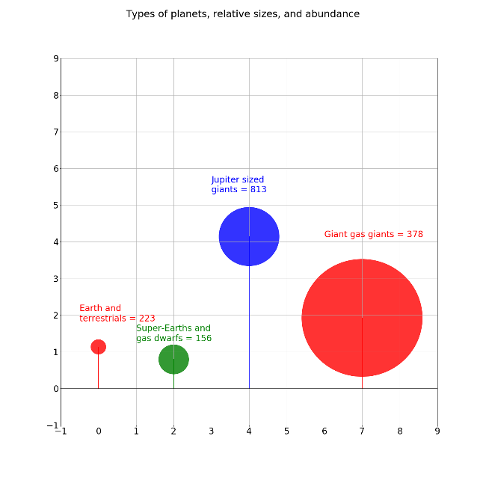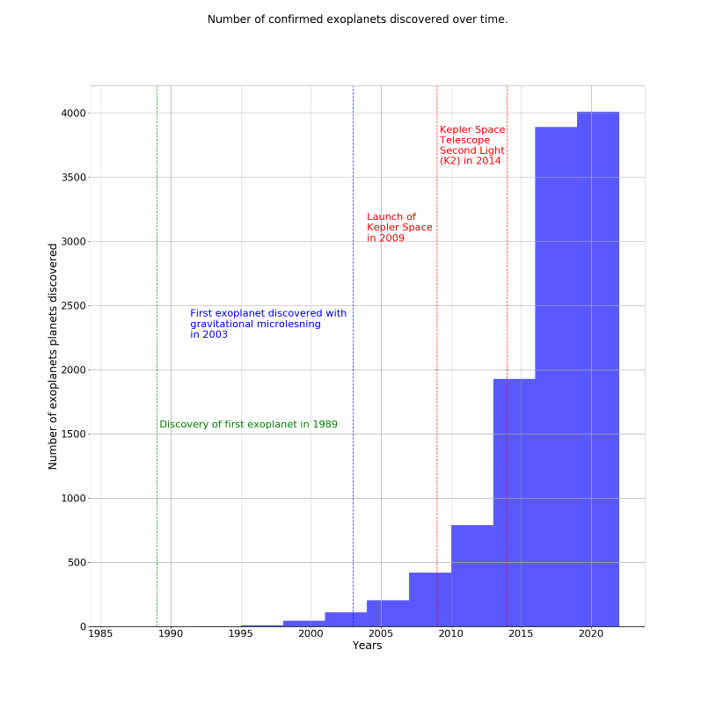Encyclopaedia Galactica

For the last 30 years extrasolar planets or ‘exoplanets’ have been

discovered orbiting stars across the Milky Way Galaxy. Exoplanets

exist in various sizes are found in foreign solar systems of

many different types of host stars. The study of exoplanets

may provide humanity with clues regarding the potential

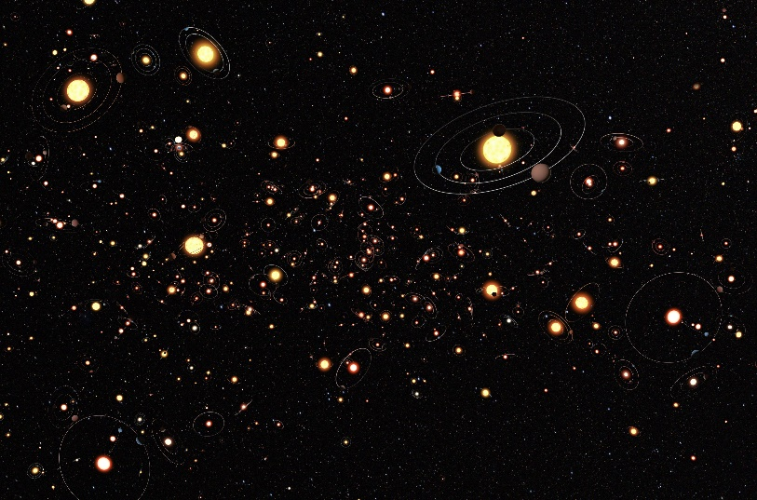existence of life elsewhere in the Universe.

